**Background: Growing demand for patient monitoring in non-hospital settings (pulse oximeter)**

**The major factors driving the demand for home healthcare include the rapidly growing global geriatric population, changing epidemiology, and the availability of cost-effective home care devices and services as compared to hospital-based care.** The delivery of quality care in non-hospital settings has resulted in better patient compliance, proactive treatments, improved patient satisfaction, and improved care quality. The necessity to frequently monitor the blood oxygen saturation of patients tested with COVID-19 has also increased the demand for pulse oximeters in home healthcare settings, as it allows patients to share their vital sign parameters such as SpO2 and temperature with their treating physician using teleconsultation.  **The advent of technological innovation in fingertip and handheld pulse oximeters enables easy storage and transfer of patient data to the care provider. Handheld pulse oximeters are easy-to-use self-monitoring devices that enable the user to share data with healthcare providers from the comfort of their home using either telemedicine services or real-time health monitoring services.** The adoption of handheld pulse oximeters is higher among **the elderly population as they prefer home care over inpatient care, owing to ease of convenience and reduced healthcare costs.**

The top market players in the global pulse oximeter market include Medtronic plc (Ireland), Masimo (US), Koninklijke Philips N.V. (Netherlands), Nonin Medical Inc. (US), Meditech Equipment Co., Ltd. (Meditech Group) (China), Contec Medical Systems Co., Ltd. (China), General Electric Company (US), ChoiceMMed (China), OSI Systems, Inc. (US), Nihon Kohden Corporation (Japan), Smiths Group plc (UK).

[**https://www.marketsandmarkets.com/Market-Reports/pulse-oximeter-market-68168578.html**](https://www.marketsandmarkets.com/Market-Reports/pulse-oximeter-market-68168578.html)

**Accuracy differences in pulse oximeter due to:**

• anemia

• **low blood pressure**

• **skin with more pigment**

• **low body temperature**

• intravascular dyes, which are used at a hospital for certain tests

<https://www.who.int/patientsafety/safesurgery/pulse_oximetry/current_product_manufacturing_options.pdf>

**Factors of pulse oximeter design:**

**Bluetooth technology:** Some brands enable their customers to connect the pulse oximeter to their smartphones or other Bluetooth-enabled devices. This may be helpful if a person wishes to review the results with a healthcare professional.

**Adjustable brightness:** Some devices come with an adjustable brightness feature to make it easier to read in a variety of light conditions.

**Large digits:** Devices that provide readings with large digits may be helpful for older adults and individuals with limited vision.

**Purpose:** A person living with certain medical conditions should check with a doctor before making a purchase, as some devices may not be suitable for their medical use. People who need the device for sports or other recreational activities do not need a medical grade device.

**Fitting:** Some devices may fit children or adults who have small fingers. Larger devices may be better for people with bigger fingers, but they will not work as well on smaller digits.

**Hypoallergenic components:** Some devices have a hypoallergenic silicone finger chamber, which may be best for people with allergies or for children.

**Reusable Ear Clip Pulse Oximetry Sensor:**

1. **NONIN 8000Q2 (with manual)**

The Nonin 8000Q2 reusable ear clip sensor offers flexibility for spot check and longer-term SpO2 monitoring when digits are not the preferred application site. With Nonin PureLight® sensor technology and PureSAT® signal processing technology, you can be sure you're getting consistent results from patient to patient and sensor to sensor.

Website: <https://www.nonin.com/products/8000q2/?correlationId=7dee3fb1-8d17-4bb9-b5cc-b380af0486e6>

Product advantages and highlight:



**Fingertip pulse oximeter**

1. **Santamedical Generation 2 Fingertip Pulse Oximeter Oximetry Blood Oxygen Saturation Monitor with Batteries and Lanyard**

Website:

[Amazon.com: Santamedical Generation 2 Fingertip Pulse Oximeter Oximetry Blood Oxygen Saturation Monitor with Batteries and Lanyard : Health & Household](https://www.amazon.com/Santamedical-Generation-Fingertip-Saturation-Batteries/dp/B000ORVXPA?ref_=ast_sto_dp)

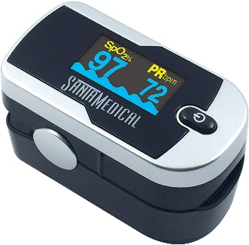

Advantages and Highlight:

* Accurate reading
* Fast and easy to use - Taking your oxygen and pulse readings with this digital oximeter is as simple as pressing a button. It uses patented technology and can show readings in four different directions with 6 display. Taking the SpO2 readings (blood oxygen saturation levels) at convenience of your home or outdoor
* Bright and compact - Bright OLED display allows clear reading in dark, inside home or in bright sunlight. Oxygen saturation monitor shows real time Pulse Rate, Pulse Rate Bar and SpO2 level. Light Weight, Easy to carry & Accommodates wide range of finger sizes.
* Light
* Long battery life

1. **OXILINE Pulse 7 Pro**

**Website: (only little information)**

<https://oxiline.shop/product/oxiline-pulse/?correlationId=72c1ca2d-c474-4e26-81f7-2b4866ff594d>

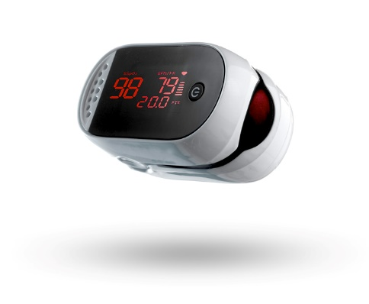

Advantages and highlight:

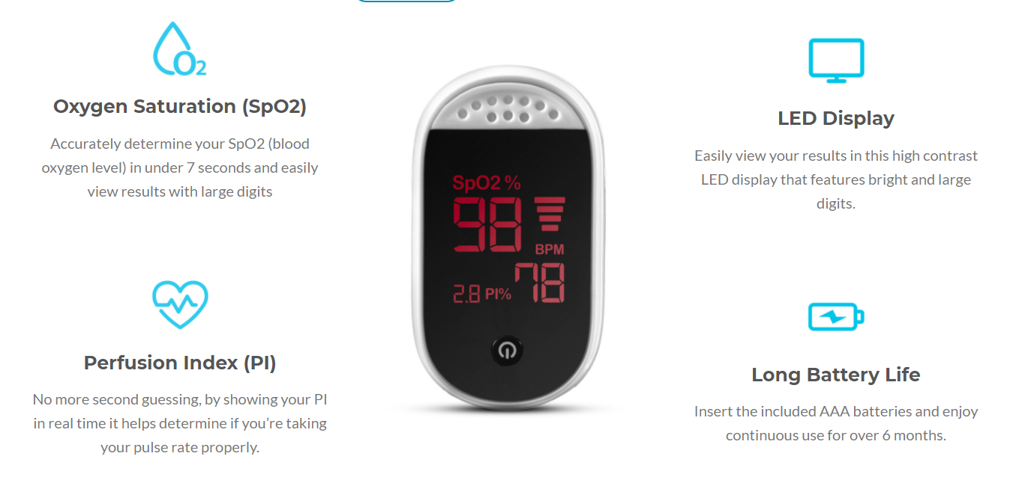

Specification:

1. **Innovo Premium iP900BP Fingertip Pulse Oximeter Blood Oxygen Monitor with Plethysmograph and Perfusion Index**

Website:

<https://www.amazon.com/Innovo-Fingertip-Oximeter-Plethysmograph-Perfusion/dp/B077ZJ1ZKZ?&linkCode=ll1&tag=best-pulse-oximeters-20&linkId=c2fadacd2a83e99c86f15ff728a3ede9&language=en_US&ref_=as_li_ss_tl&correlationId=c72aee2e-0b94-4a5f-9c33-9c1e6cc52127>

Description:

* ACCURATE AND RELIABLE - Accurately determine your SpO2 (blood oxygen saturation levels), Pulse Rate and Pulse Strength within seconds.
* PLETHYSMOGRAPH AND PERFUSION INDEX - Premium features that indicate the optimal time to take a reading. No more second guessing if you are taking your SpO2 and Pulse Rate properly.
* ADJUSTABLE OLED DISPLAY - Patented rotatable display with 6 layout options allow you to view your results conveniently in any direction.
* SPORTS ENTHUSIASTS - Suitable for mountain climbers, skiers, bikers, aviators or anyone interested in measuring their SpO2 and pulse rate while on the move.

1. **Nellcor™ SpO₂ Forehead Sensor with OxiMax™ Technology**

The PO 45 pulse oximeter is the ideal accessory for sport activities at altitude. Whether you’re a mountaineer, skier or amateur pilot, this handy little device gives an overview of your oxygen saturation at all times.

Website:

<https://www.beurer.com/web/gb/products/medical/ecg-and-pulse-oximeter/pulse-oximeter/po-45.php>

Highlight:

Particularly suitable for persons with: heart failure, chronic obstructive pulmonary diseases, bronchial asthma

Suitable for sport at high altitudes (e.g. mountaineering, skiing and aviation sports)

Symbol display in case of erratic measurement

Colour display with 7 display formats

Adjustable display brightness

Graphic pulse display

Low battery indicator

Automatic switch-off

 **(manual)**

1. **MightySat® Rx Fingertip Pulse Oximeter**

**Website:**

[**https://www.masimo.com/products/monitors/spot-check/mightysatrx/**](https://www.masimo.com/products/monitors/spot-check/mightysatrx/)

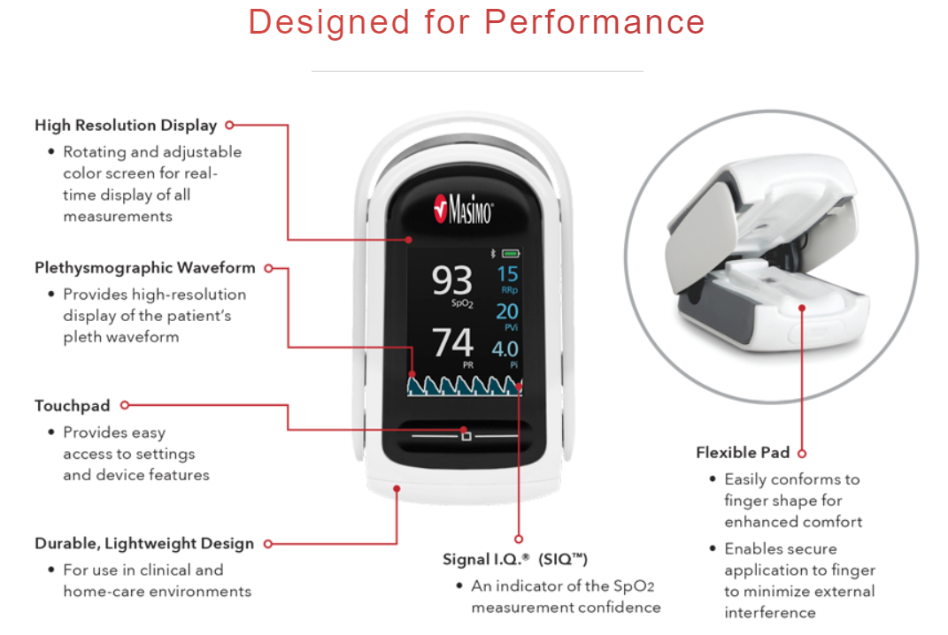

1. **iHealth Air Wireless Fingertip Pulse Oximeter**

**website:**

[**https://www.amazon.com/iHealth-Fingertip-Plethysmograph-Perfusion-Saturation/dp/B00D7MDXCU?&linkCode=ll1&tag=mnt-best-pulse-oximeters-20&linkId=399cc4600e8e3828cb1ef07f793f52f6&language=en_US&ref_=as_li_ss_tl&correlationId=d113e79b-20ff-4eac-8605-c186b006a516**](https://www.amazon.com/iHealth-Fingertip-Plethysmograph-Perfusion-Saturation/dp/B00D7MDXCU?&linkCode=ll1&tag=mnt-best-pulse-oximeters-20&linkId=399cc4600e8e3828cb1ef07f793f52f6&language=en_US&ref_=as_li_ss_tl&correlationId=d113e79b-20ff-4eac-8605-c186b006a516)

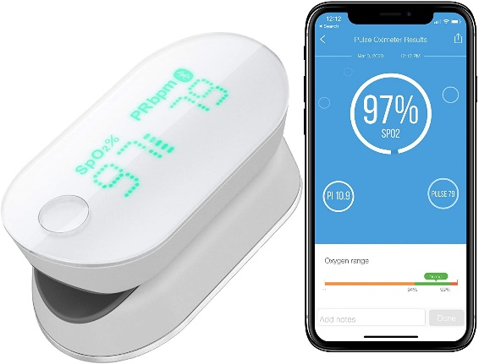

**Advantages and highlights:**

* Accurate and Reliable - Trusted smart blood pulse oximeter for many telemedicine programs in the U.S. Accurately detect your SpO2 ( blood oxygen saturation levels) , pulse rate and pulse strength in seconds and display results conveniently on a XL digit LED display and even in your smartphone.
* 99% SpO2 Value- iHealth Air Bluetooth pulse oximeter that can read and display up to 99% for SpO2.
* **Smart App & More Details - With the help fo the free iHealth Myvitals App, you can simultaneously track those results in the app and see the real time plethysmograph (The SpO2 waveform) and Perfusion index. All your results will be stored in the app and free secured iHealth cloud. Powerful digital logbook in the app and no more hand writing.**
* **Sport & Health Enthusiasts- Suitable for mountain climbers, skiers, bikers, aviators or anyone interested in measuring their SpO2 and pulse rate while on the move.**You should only use the pulse oximeter before or after your exercise when you remain stationary.
* **Built-in Li-On Battery** save lots of hassle for extra cost.Packaged with accessories: A high quality lanyard for easy to go. Micro-USB for simply charging the oximeter. Comes with 12 months WARRANTY and California based support.

**Pulse Oximeter with Forehead Sensor**

**1. Nellcor™ SpO₂ Forehead Sensor with OxiMax™ Technology**

website

<https://www.medtronic.com/covidien/en-us/products/pulse-oximetry/nellcor-spo2-forehead-sensor.html?correlationId=da4500ca-70bd-4462-8da0-9876be0bf48d>

Highlight:

Get accurate data – quickly

Nellcor™ pulse oximetry with OxiMax™ technology specifies a highly accurate measurement of SpO2, even in some of the most challenging patients.5

The Nellcor™ SpO2 forehead sensor:

Provides an expanded LoSat accuracy range of 60% – 80% SpO2 +/-3 and delivers reliable readings in challenging conditions4

Designed for an accessible sensor site-the forehead is generally easier to reach and less prone to motion than hands

Can be used with mechanically ventilated patients

Enables monitoring of patients from pediatric (weighing more than 10 kg) to adult

Single-patient use, featuring long-lasting, four-layer adhesive

1. **Oxxiom RX (disposable)**

The Oxxiom Pulse Oximetry System is a **wireless, fully disposable, single-use device** for measuring and displaying functional oxygen saturation of arterial hemoglobin (SpO2) and pulse rate (PR). It also measures Pulse Amplitude (PA). It is a prescription device for spot checking, intermittent monitoring, and data collection.

The Oxxiom Pulse Oximetry System has two main components, **the Oxxiom device (hardware device) and the Oxxiom Rx App**. The Oxxiom device does not have a dedicated display or alarm system. It requires a handheld iOS device for use. The iOS device can be an iPhone, iPad, or iPod.

The Oxxiom device is small, lightweight, and has a maximum duration of 24 hours of use. It simultaneously and wirelessly transfers all collected data to the Oxxiom Rx App on the iOS device, which analyzes data, displays information, provides warnings as necessary, and stores the information.

Website:

<https://www.truewearables.com/>

User guideline:



**Finger ring pulse oximeter**

**1. O2 Ring**

**Website:**

[**https://getwellue.com/pages/o2ring-oxygen-monitor**](https://getwellue.com/pages/o2ring-oxygen-monitor)

**Highlight:**

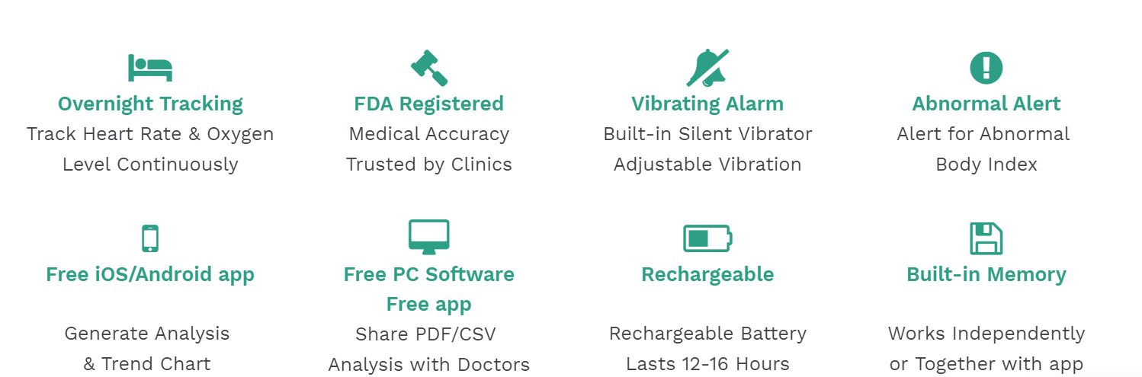

**Design:**

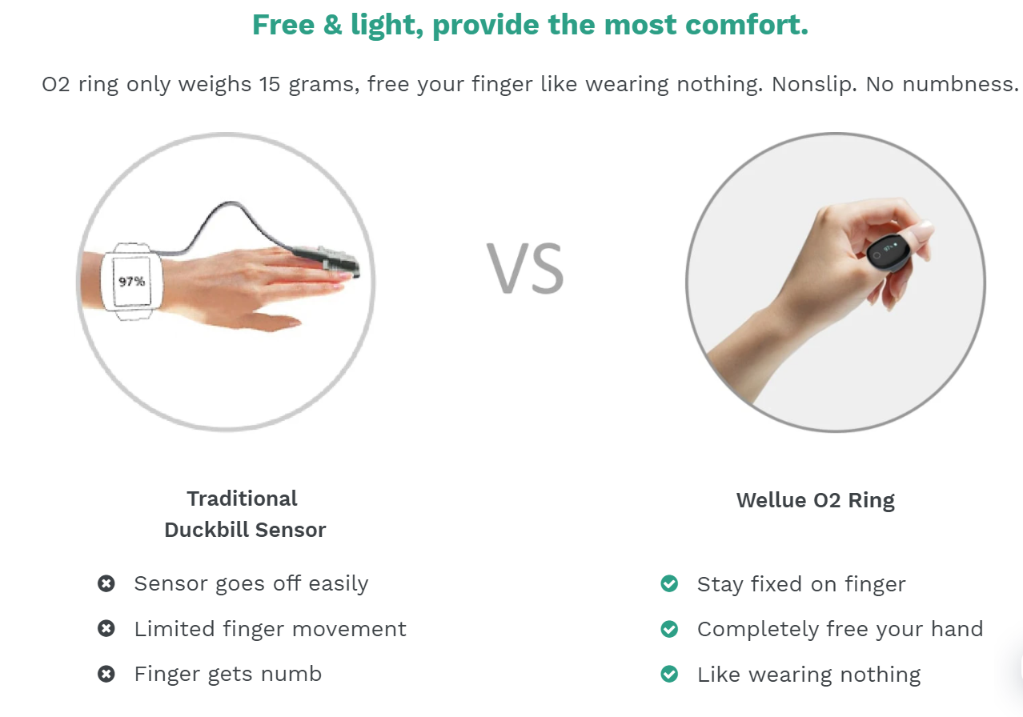

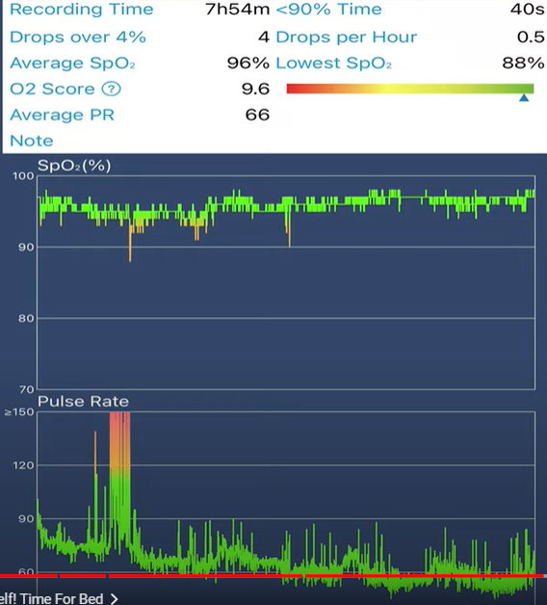

**Youtube:** [**https://www.youtube.com/watch?v=N8FMw3CeDN0**](https://www.youtube.com/watch?v=N8FMw3CeDN0)

[**https://www.youtube.com/watch?v=TKH0Z7sSK7g**](https://www.youtube.com/watch?v=TKH0Z7sSK7g) **(with mechanism)**

1. **Megahealth Ring (HKUST Joint Shanghai Megahealth)**

**Website:**

[**https://www.arm.com/why-arm/innovation/arm-designs/wearables-technology**](https://www.arm.com/why-arm/innovation/arm-designs/wearables-technology)

**Highlight:**

The Bluetooth low-energy wearable ring uses an **nRF52832 system on chip (SoC)** for the ring’s core microcontroller, based on powerful 64-MHz, 32-bit Arm Cortex-M4F processor technology. This processor enables SpO2 signal acquisition and algorithm operation. The Nordic SoC’s 512 kB Flash memory is sufficient to easily store and record the data, while the 64 kB RAM is ample for the device’s algorithm filtering requirements. In addition, the Nordic SoC provides low latency Bluetooth Low Energy wireless connectivity-enabling data to be periodically transmitted from the device to an individual’s Bluetooth 4.0 (and later) smartphone.

**Youtube:** [**https://www.youtube.com/watch?v=HuCTYmHZDPY**](https://www.youtube.com/watch?v=HuCTYmHZDPY)

1. **Lookee Ring Sleep Monitor**

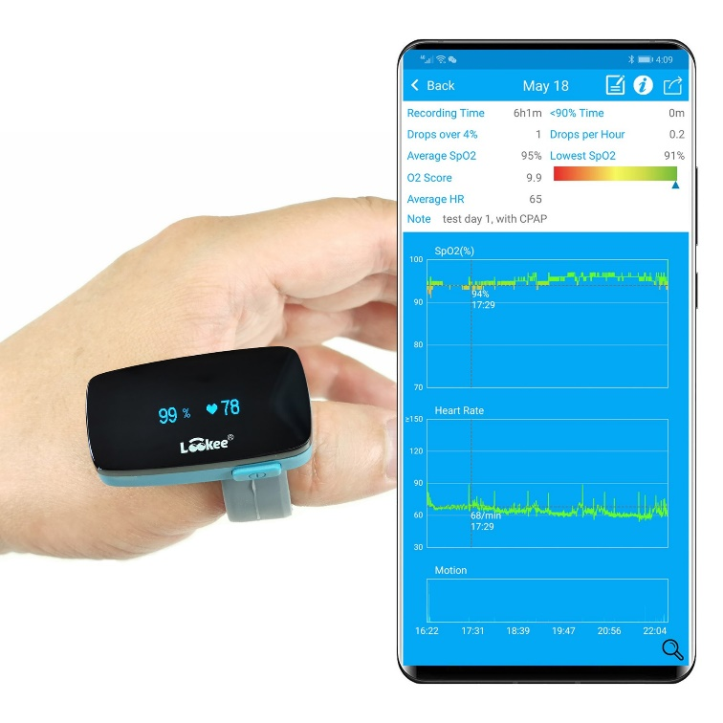

**Website:**

[**https://www.lookeetech.com/products/lookee-ring-sleep-monitor-w-vibrating-notification-for-sleep-apnea**](https://www.lookeetech.com/products/lookee-ring-sleep-monitor-w-vibrating-notification-for-sleep-apnea)

1. **Oura ring (no SpO2 monitoring)**

**Website:**

[**https://ouraring.com/meet-oura**](https://ouraring.com/meet-oura)

**highlight:**

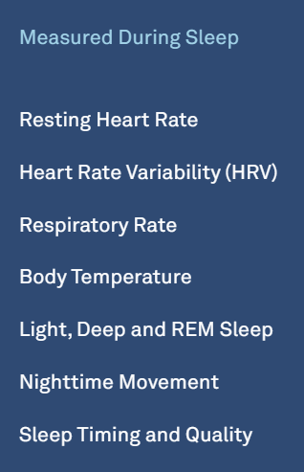

**Wrist Pulse Oximeter (excluding fitness band and smart watch coz they’re too many in the market)**

**1. Oxitone 1000M**

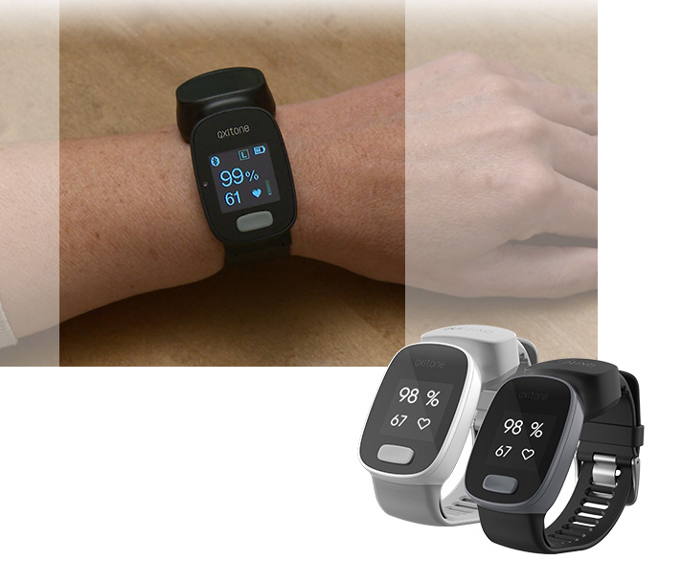

**Website:**

[**https://www.oxitone.com/oxitone-1000m/**](https://www.oxitone.com/oxitone-1000m/)

**Highlight:**

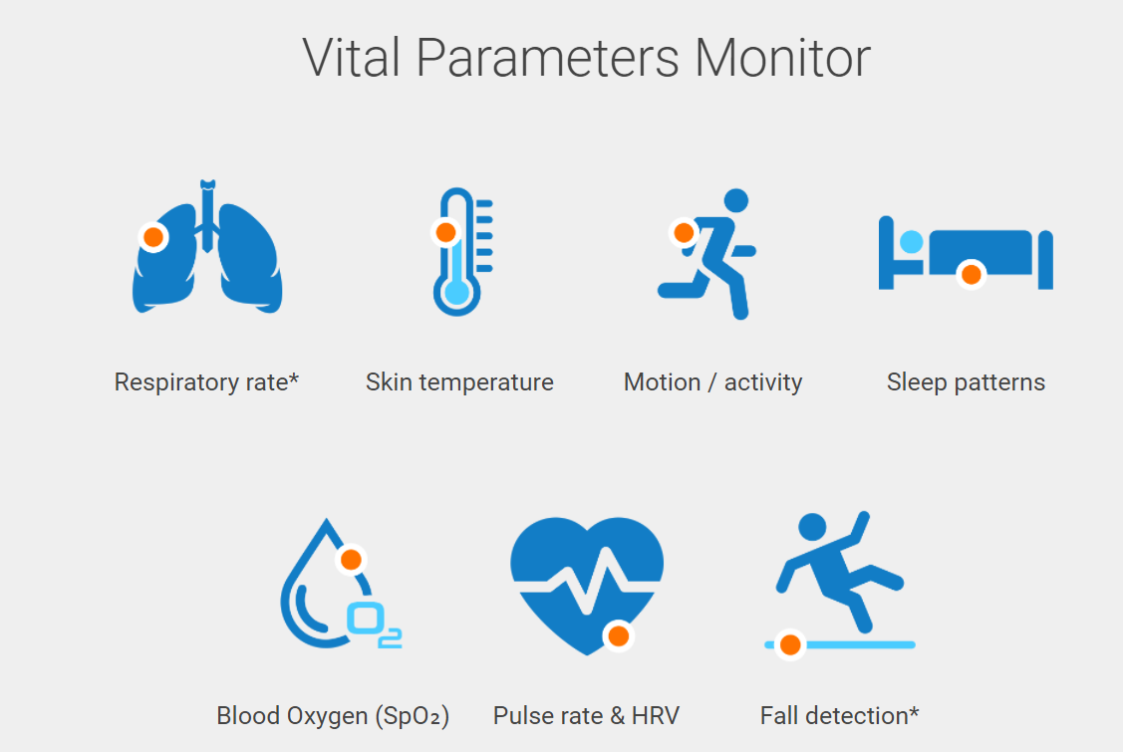

**Specification:**



1. **NONIN 3150 USB WRISTOX2 WRIST PULSE OXIMETER**

**Website:**

[**https://www.nonin.com/products/3150-usb/**](https://www.nonin.com/products/3150-usb/)

**specification:**



1. **Wellue SleepU™**

FDA listed Wellue® SleepU™ is compact and lipstick-sized, simply wear it on your wrist for a full night, it records your blood oxygen saturation, heart rate and body movements every second continuously.

**Website:**

[**https://getwellue.com/pages/sleepu-oxygen-monitor**](https://getwellue.com/pages/sleepu-oxygen-monitor)

